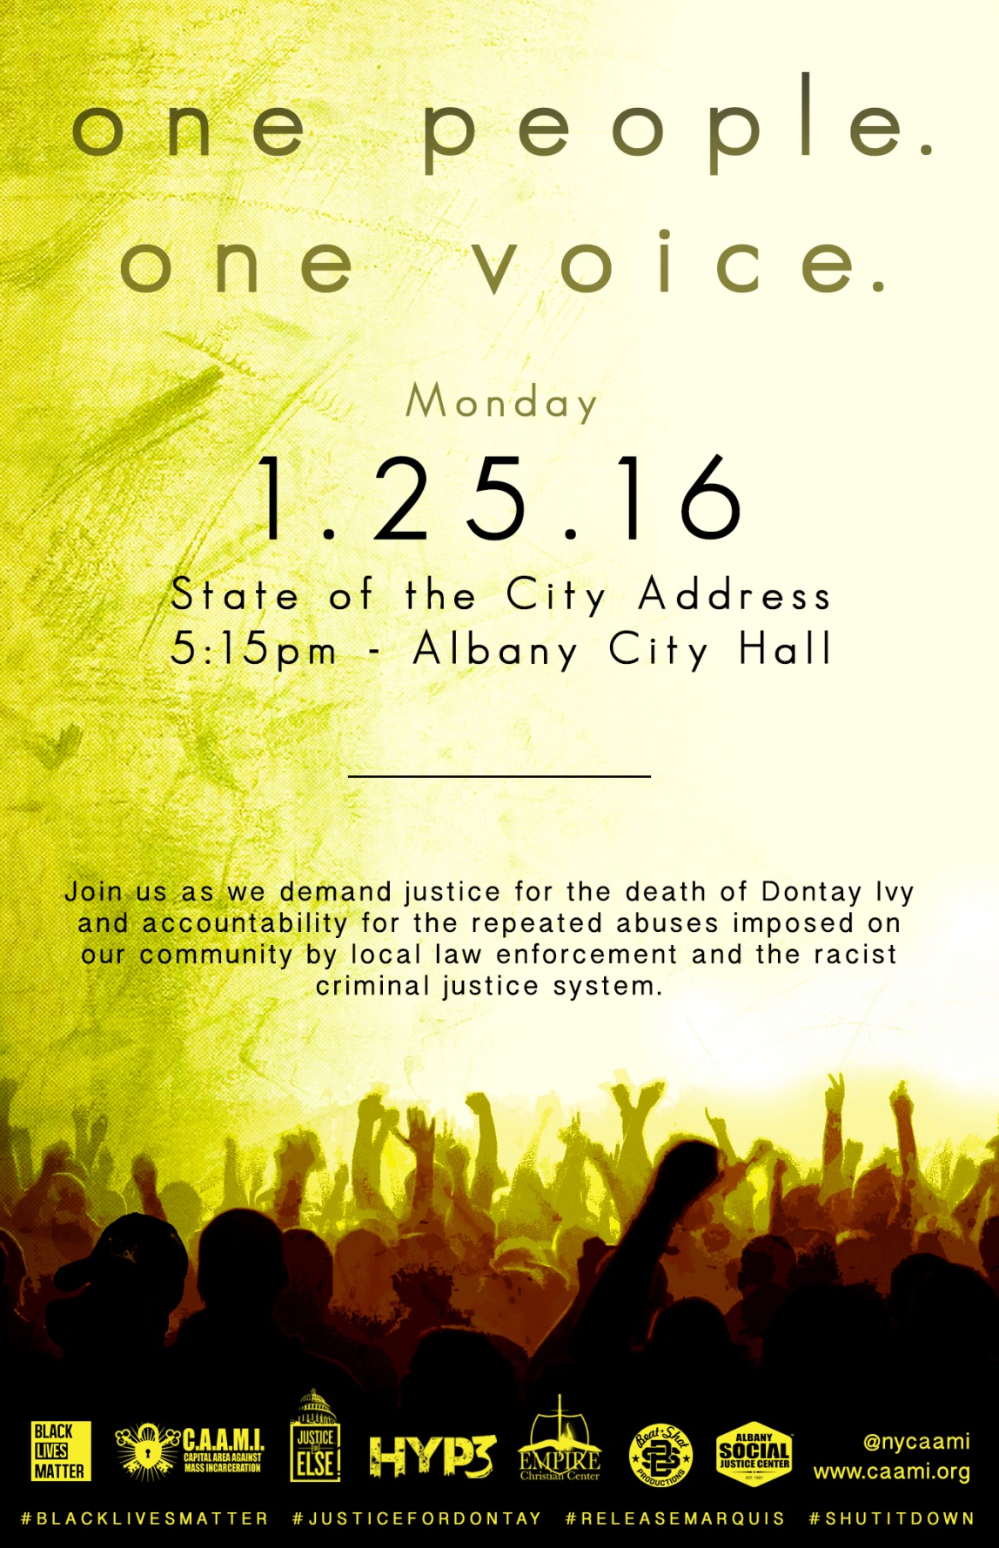

JUSTICE FOR DONTAY IVY
Shortly after midnight on April 2, 2015, three Albany police officers (Michael Mahany, Joshua Sears and Charles Skinkle) unconstitutionally stopped a member of our community for having a "suspicious" walk and one of his hands in his sleeve. He was questioned, detained, and ultimately tased to death. That community member’s name was Dontay Ivy—a father, and former Albany High athlete and honor student, who graduated from Virginia State University. Dontay had a history of heart problems and was living with schizophrenia.
On Oct. 28th, 2015, after a sloppy 7 month investigation dragged out by an incompetent District Attorney’s office, a grand jury chose not to levy any charges against the officers that killed Dontay. This has left members of Dontay’s family and the community devastated. When Dontay was originally taken from us, over 300 people came out to protest his murder.
Join us as we demand justice for Dontay Ivy, and accountability of those responsible for his death.
One people. One voice. #JusticeForDontay
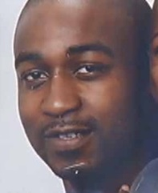
-Capital Area Against Mass Incarceration
In conjunction with:
Social Justice Center of Albany
Black Lives Matter Network
Justice Or Else
Empire Christian Center
HYP3 Entertainment
Beat*Shot Productions
and more.
WHAT CAN YOU DO TO HELP?
•Call the Mayor at (518) 434-5100 and demand the immediate firing of the officers responsible for Dontay’s death and an end to racial profiling by the APD.
•Spread the word about Dontay’s case via mainstream and social media, by attending public actions and following/supporting the efforts of Capital Area Against Mass Incarceration on Facebook and Twitter.
•Help us organize and engage the community by hosting a house meeting to increase neighborhood-level support and involvement. [For details contact Angelica Clarke, Executive Director of the Social Justice Center at (518) 209-5231]
#JUSTICEFORDONTAY // #LIGHTITUP // WWW.CAAMI.ORG

JUSTICE FOR DONTAY IVY
Shortly after midnight on April 2, 2015, three Albany police officers (Michael Mahany, Joshua Sears and Charles Skinkle) unconstitutionally stopped a member of our community for having a "suspicious" walk and one of his hands in his sleeve. He was questioned, detained, and ultimately tased to death. That community member’s name was Dontay Ivy—a father, and former Albany High athlete and honor student, who graduated from Virginia State University. Dontay had a history of heart problems and was living with schizophrenia.
On Oct. 28th, 2015, after a sloppy 7 month investigation dragged out by an incompetent District Attorney’s office, a grand jury chose not to levy any charges against the officers that killed Dontay. This has left members of Dontay’s family and the community devastated. When Dontay was originally taken from us, over 300 people came out to protest his murder.
Join us as we demand justice for Dontay Ivy, and accountability of those responsible for his death.
One people. One voice. #JusticeForDontay
-Capital Area Against Mass Incarceration
In conjunction with:
Social Justice Center of Albany
Black Lives Matter Network
Justice Or Else
Empire Christian Center
HYP3 Entertainment
Beat*Shot Productions
and more."
WHAT CAN YOU DO TO HELP?
•Call the Mayor at (518) 434-5100 and demand the immediate firing of the officers responsible for Dontay’s death and an end to racial profiling by the APD.
•Spread the word about Dontay’s case via mainstream and social media, by attending public actions and following/supporting the efforts of Capital Area Against Mass Incarceration on Facebook and Twitter.
•Help us organize and engage the community by hosting a house meeting to increase neighborhood-level support and involvement. [For details contact Angelica Clarke, Executive Director of the Social Justice Center at (518) 209-5231]
#JUSTICEFORDONTAY // #LIGHTITUP // WWW.CAAMI.ORG

